BHARATCARES – AICTE INTERNSHIP PROGRAM
in collaboration with IBM SkillsBuild

PROJECT REPORT
SOLAR POWER ANALYTICS
Utility-Scale Solar Power Generation Analytics & Predictive O&M

Submitted by
NIKITA DASH
Internship ID: IBMUEDA4657
Goswami Ganesh Dutta Sanatan Dharma College
IBM SkillsBuild Data Analytics with AI Internship 2026
Internship period: 17 August 2026 – 30 September 2026

Project Repository
github.com/nikitadash28/SOLAR_POWER_ANALYTICS

Internship Context
The supplied offer letter identifies Nikita Dash (Internship ID IBMUEDA4657) as selected for the six-week virtual IBM SkillsBuild Data Analytics with AI Internship 2026, offered in collaboration with AICTE. It states that the internship runs from 17 August 2026 to 30 September 2026 and is designed around Data Science, Data Analytics, AI tools, predictive modeling, machine learning and real-world project development.
The letter's timeline covers data cleaning and preprocessing, exploratory data analysis, predictive analytics, machine learning basics, AI-driven insights and visualization, followed by project completion and submission. This report is structured to document a project that demonstrates that progression.
Program | IBM SkillsBuild Data Analytics with AI Internship 2026
Internship ID | IBMUEDA4657
Student | Nikita Dash
College stated in undertaking | Goswami Ganesh Dutta Sanatan Dharma College
Internship duration | 17 August 2026 – 30 September 2026
Project domain | Renewable Energy, Data Analytics, Machine Learning and Predictive O&M

Declaration
I, Nikita Dash, declare that this report titled “Solar Power Analytics: Utility-Scale Solar Power Generation Analytics & Predictive O&M” has been prepared for submission as the final project component of the IBM SkillsBuild Data Analytics with AI Internship 2026 offered in collaboration with AICTE.
The technical descriptions and reported results in this report are grounded in the project repository and the supplied internship documentation. The report does not represent the internship completion certificate as already issued.
Student | Signature | Date
Nikita Dash | ____________________ | ____________________

Acknowledgement
I sincerely thank the BharatCares–AICTE–IBM SkillsBuild internship program for providing a structured learning environment in Data Analytics with AI. The internship framework provided exposure to data cleaning, exploratory analysis, predictive analytics, machine learning and AI-driven visualization.
I also acknowledge the mentors, subject-matter experts and program team for the learning structure and guidance, and my college, Goswami Ganesh Dutta Sanatan Dharma College, for supporting my participation in the internship and project submission process.

Executive Summary
This project develops an end-to-end analytics workflow for utility-scale solar generation data using a four-tier ladder: Descriptive, Diagnostic, Predictive and Prescriptive analytics.
The repository documents 34 days of 15-minute telemetry from 22 central inverters, containing 68,778 records. Data-quality checks are followed by inverter-day aggregation, producing 748 observations. The predictive target is a Low_Generation_Flag defined by the bottom quartile of daily yield.
The project reports a Random Forest accuracy of 97.33%, precision of 100%, recall of 89.19%, F1-score of 0.9429 and ROC-AUC of 0.9983 on the stated evaluation setup. The prescriptive layer converts predicted risk into a resource-constrained Top-K inspection strategy.

Abstract
This project presents a data analytics and machine learning framework for monitoring utility-scale solar power generation and supporting predictive operation and maintenance. High-frequency telemetry is processed through data-quality validation, temporal aggregation, exploratory analysis and supervised learning.
The workflow uses 68,778 15-minute records covering 34 days and 22 central inverters. The resulting inverter-day dataset contains 748 observations. A binary Low_Generation_Flag is created using a 6,331.75 kWh bottom-quartile threshold.
Random Forest is compared with Logistic Regression. The repository reports 97.33% accuracy and 0.9983 ROC-AUC for Random Forest. Feature engineering uses irradiation, temperature, thermal differential, lagged inverter state, rolling yield and calendar variables while excluding current-day yield and power derivatives.
Keywords: Solar Energy, Data Analytics, Predictive Maintenance, Machine Learning, Random Forest, SCADA, Inverter Monitoring, Streamlit, Renewable Energy, AI.

1. Introduction

1.1 Background
Utility-scale photovoltaic plants continuously generate operational data from inverters and environmental sensors. When these observations are analyzed at the right temporal and asset level, they can support performance benchmarking, anomaly identification and maintenance prioritization.

1.2 Motivation
Solar generation varies naturally with irradiance, time of day and weather. An O&M team with limited daily capacity therefore needs a way to prioritize assets rather than inspect every inverter with equal frequency.

1.3 Objectives
- Understand temporal generation patterns.
- Measure inverter-level performance variation.
- Identify environmental and thermal relationships.
- Construct a leakage-aware low-generation target.
- Train and compare supervised classifiers.
- Evaluate models with accuracy, precision, recall, F1-score and ROC-AUC.
- Translate predicted risk into maintenance prioritization.
- Provide an interactive Streamlit dashboard.

2. Internship Learning Alignment
The offer letter describes a six-week learning structure covering data analytics, preprocessing, EDA, predictive analytics, machine learning, AI-driven insights and visualization. The project maps directly onto these areas.
Learning area | Project demonstration
Data cleaning and preprocessing | Null/duplicate audit, sensor drift handling and inverter-day aggregation
EDA | Diurnal curves, inverter cohorts and correlation analysis
Predictive analytics | Low-generation classification target
Machine learning | Random Forest and Logistic Regression
AI-driven visualization | Streamlit dashboard and Plotly analytics
Final project | GitHub repository, dashboard and this report

3. Problem Statement and Objectives
A utility-scale solar plant must maintain high generation availability while operating with finite O&M resources. The project asks how telemetry can be transformed into a workflow that identifies low-generation risk, distinguishes environmental variation from localized asset issues, and prioritizes a limited number of daily inspections.
The primary objective is to move from historical reporting toward predictive and prescriptive decision support without using variables that directly leak the target.

4. Domain Background
Photovoltaic modules convert incident solar radiation into direct-current power. Inverters convert DC power into AC power suitable for grid injection. The project monitors DC power, AC power, daily and total yield, irradiation and temperature.
Inverter-level differences can indicate localized conditions such as soiling, degradation or electrical issues. The project therefore uses inverter identifiers for analysis but removes raw IDs from predictive features.
Thermal behavior is examined diagnostically because high module temperatures can coincide with reduced conversion performance. The repository explicitly distinguishes correlation from causation when interpreting temperature and power relationships.

5. Dataset Description
The repository documents Plant ID 4135001 with 22 central inverters and a 34-day period from 15 May 2020 to 17 June 2020 at 15-minute intervals, producing 68,778 records.
Variable | Type / Unit | Documented information
DATE_TIME | datetime | 15-minute observations
PLANT_ID | integer | 4135001
SOURCE_KEY | categorical | 22 unique inverter IDs
DC_POWER | kW | 0.0 to 14,471.1
AC_POWER | kW | 0.0 to 1,410.9
DAILY_YIELD | kWh | 0.0 to 9,163.0
TOTAL_YIELD | kWh | 6.25M to 7.85M
AMBIENT_TEMPERATURE | °C | 20.4 to 35.3
MODULE_TEMPERATURE | °C | 18.1 to 65.5
IRRADIATION | kW/m² | 0.0 to 1.22

6. Data Engineering and Quality Assurance
The dashboard loads the CSV directly using Pandas. The documented audit reports zero null values and zero duplicate timestamp-inverter combinations. Minor negative night-time sensor drift is lower-clipped to zero.
The 68,778 observations are aggregated to 748 inverter-day entities (22 inverters × 34 days). This reduces night-time zero inflation and aligns the data with daily O&M decisions.
Leakage controls exclude current-day DAILY_YIELD, TOTAL_DC_POWER and TOTAL_AC_POWER. Raw SOURCE_KEY and PLANT_ID are also excluded from the model. Permitted predictors are environmental statistics, prior-day asset-state variables and seasonality.

7. Four-Tier Analytics Methodology
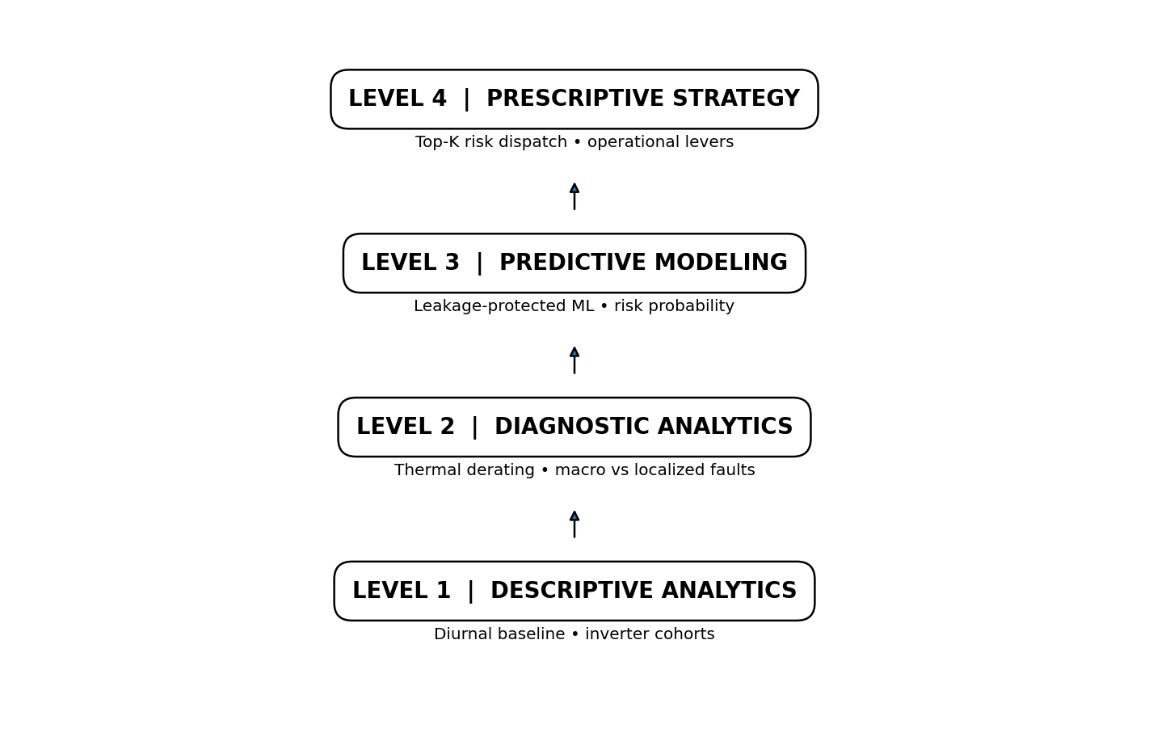
Figure. Project-native / reconstructed visualization based on repository-documented results.
The four levels progress from understanding historical behavior to deciding what action should be taken. Descriptive patterns inform diagnostics; diagnostics inform feature engineering; predictive risk supports prioritization; prescriptive rules connect risk to O&M actions.
Level 1 answers “What happened?”, Level 2 asks “Why did it happen?”, Level 3 asks “What will happen?”, and Level 4 asks “What should be done?”

8. Descriptive Analytics
The repository reports a synchronized diurnal bell curve for DC power, AC power and solar irradiance. Generation begins around 06:00, peaks between approximately 11:30 and 13:30, and returns toward zero by about 18:45.
The inverter cohort analysis reports clear dispersion among assets, with some units showing median daily yield above 7,400 kWh and other units showing wider variance and floors below 4,500 kWh.
These findings establish an operational baseline and show why time-of-day context and asset-level benchmarking are important.

9. Diagnostic Analytics
The thermal diagnostic reports a downward empirical trend in conversion efficiency as module temperatures rise from about 30°C toward above 65°C under high solar loading.
Daily plant output ranges from approximately 195 MWh on peak clear-sky days to below 85 MWh on the overcast days highlighted in the repository. Fleet-wide movements can indicate meteorological effects, while isolated inverter deviations can indicate localized problems.
The correlation matrix reports r = 0.99 between DC and AC power and r = 0.72 between Daily Yield and the relevant electrical relationships. The project uses these correlations to justify strict leakage prevention.

10. Predictive Machine Learning
Low_Generation_Flag is defined as an inverter-day below the 25th percentile of daily yield, with a documented threshold of 6,331.75 kWh. The class distribution is 561 nominal observations and 187 low-generation observations.
Feature group | Predictors
Environmental | TOTAL_IRRADIATION, PEAK_IRRADIATION, MEAN_AMB_TEMP, MAX_AMB_TEMP, MEAN_MOD_TEMP, MAX_MOD_TEMP, PEAK_THERMAL_DIFF
Prior-day asset state | LAG1_EFFICIENCY, LAG1_YIELD, ROLLING_3D_YIELD_MEAN
Seasonality | DAY_OF_WEEK, DAY_OF_YEAR
Excluded | Current-day yield/power derivatives, SOURCE_KEY, PLANT_ID
The implementation uses RandomForestClassifier with 100 estimators, maximum depth 5 and random state 42. Logistic Regression with StandardScaler provides the baseline. Both use an 80/20 stratified split.

11. Model Evaluation and Interpretation
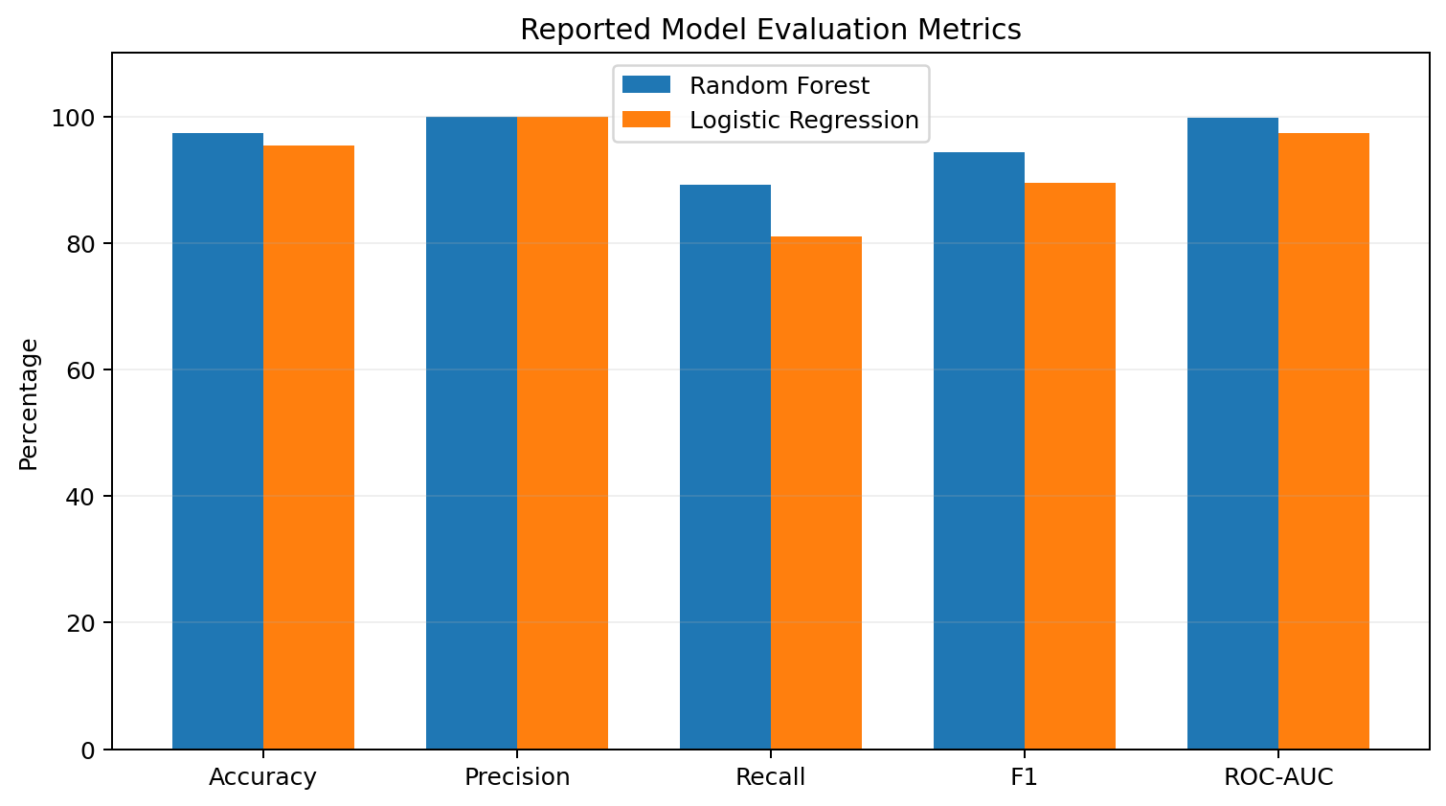
Figure. Project-native / reconstructed visualization based on repository-documented results.
The repository reports the following evaluation results.
Metric | Random Forest | Logistic Regression | Operational target
Accuracy | 97.33% | 95.33% | >90.0%
Precision | 100.00% | 100.00% | >85.0%
Recall | 89.19% | 81.08% | >85.0%
F1 | 0.9429 | 0.8955 | >0.850
ROC-AUC | 0.9983 | 0.9739 | >0.950
For the Random Forest test set of 150 observations, the repository reports 113 true negatives, 0 false positives, 4 false negatives and 33 true positives.
Feature | Reported importance
TOTAL_IRRADIATION | 35.04%
MEAN_MOD_TEMP | 17.85%
MEAN_AMB_TEMP | 7.85%
MAX_MOD_TEMP | 7.82%
LAG1_YIELD | 5.41%
MAX_AMB_TEMP | 5.04%
DAY_OF_YEAR | 4.74%
PEAK_IRRADIATION | 4.28%
PEAK_THERMAL_DIFF | 4.18%
ROLLING_3D_YIELD_MEAN | 3.69%

12. Prescriptive Analytics and O&M Strategy
The project assumes a maximum capacity of three inverter inspections per day. The operational concept is to calculate low-generation probabilities, rank the 22 inverters and allocate inspection slots to the highest-risk assets when the top risk exceeds τ = 0.40.
Operational lever | Trigger / rule | Action
Condition-based panel washing | 3-day performance ratio >8% below cohort median in clear-sky conditions | Targeted panel washing
Thermal inverter management | Thermal gradient >25°C and risk >0.40 | Inspect cabinet cooling system
Electrical string audit | LAG1_EFFICIENCY <0.08 | Inspect combiner fuses, voltages and bypass diodes
Dawn/dusk alarm suppression | Irradiance <0.05 kW/m² | Suppress expected low-power alerts
The repository also documents financial and reliability ROI estimates for the proposed levers. These are treated in this report as project-specific scenario assumptions, not independently verified forecasts.

13. Dashboard and Software Implementation
Technology | Role
Python | Primary implementation language
Pandas | Data loading and transformation
NumPy | Numerical operations
Plotly | Interactive visualizations
scikit-learn | Machine learning and evaluation
Streamlit | Interactive dashboard
GitHub | Source and artifact hosting
The Streamlit application is organized into five tabs: Descriptive Analytics, Diagnostic Analytics, Predictive ML Engine, Prescriptive Strategy, and Data Hygiene & Audit Trail. The sidebar includes an inverter selector for fleet or asset-level analysis.
The documented startup command is python -m streamlit run app.py, launching the dashboard locally on port 8501 by default.

14. System Architecture
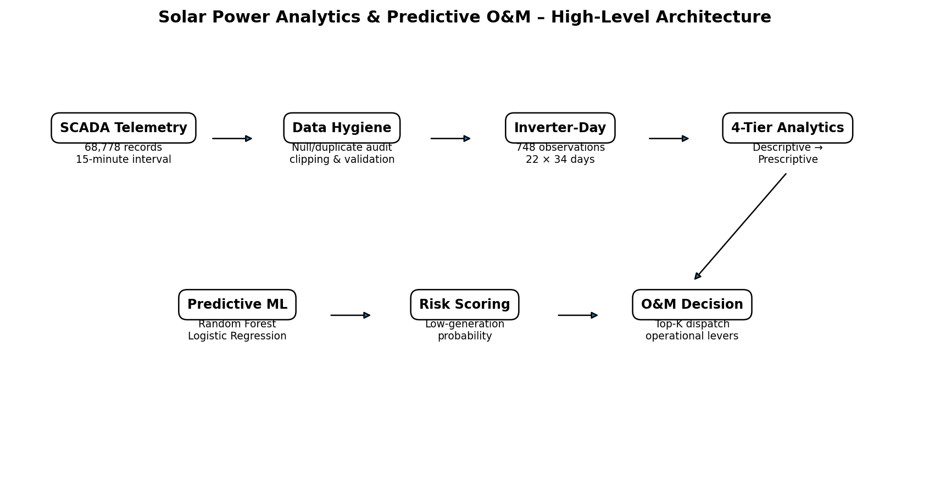
Figure. Project-native / reconstructed visualization based on repository-documented results.
The architecture begins with telemetry, proceeds through data hygiene and inverter-day aggregation, then applies the four analytics levels. Predictive risk feeds the prescriptive O&M layer, while the Streamlit application exposes the results interactively.

15. Results and Findings
Data findings: 68,778 records, 34 days, 22 inverters, zero reported nulls, zero reported duplicate timestamp-inverter pairs and 748 inverter-day observations.
Analytical findings: strong diurnal generation, heterogeneous inverter performance, thermal derating behavior and meaningful separation between fleet-wide weather effects and localized asset variation.
Machine-learning findings: Random Forest accuracy 97.33%, precision 100%, recall 89.19%, F1 0.9429 and ROC-AUC 0.9983 on the stated evaluation split. Total irradiation is the leading reported feature.

16. Testing and Verification
Test | Repository-reported outcome
Missing-value audit | 0 nulls / NaNs
Duplicate audit | 0 duplicate timestamp-inverter pairs
Sensor drift | Negative generation/irradiation readings clipped to 0
Aggregation | 748 inverter-day records
Visualizations | 5 documented charts
Leakage protection | Concurrent power/yield variables excluded
ML evaluation | Accuracy, precision, recall, F1 and ROC-AUC reported
Prescriptive logic | Top-K daily crew allocation documented
Application | Five-tab Streamlit dashboard
These checks correspond to the repository's verification checklist. This report does not claim independent reproduction of every result outside the repository environment.

17. Limitations
- The observation window is only 34 days, limiting seasonal generalization.
- The evaluation uses a single stated 80/20 stratified split rather than time-based validation.
- The target represents low generation, not a confirmed physical failure mode.
- Financial ROI values are project-specific scenario estimates.
- The model is plant-specific and may require recalibration for another plant.
- The prescriptive rules are decision-support recommendations, not substitutes for engineering safety procedures.
- The dashboard is documented as a CSV-based application rather than a live SCADA integration.

18. Future Scope
- Expand to multiple seasons and plants.
- Use time-aware validation and cross-validation.
- Evaluate additional ensemble and boosting models.
- Calibrate probabilities and optimize thresholds using explicit O&M costs.
- Add SHAP-based explanations.
- Integrate live SCADA or near-real-time telemetry.
- Add automated alerts and maintenance-ticket workflows.
- Track post-maintenance outcomes and generation recovery.
- Monitor model drift and uncertainty.

19. Internship Learning Outcomes
Skill | Demonstrated learning
Data preparation | Cleaning, validation and entity-level aggregation
EDA | Temporal, cohort and correlation analysis
Statistical reasoning | Correlation-versus-causation framing and confounding awareness
Feature engineering | Environmental, lagged, rolling and seasonality features
Machine learning | Classification, evaluation and feature importance
Model governance | Leakage prevention and assumptions
Visualization | Plotly and Streamlit dashboard
Business analytics | Risk-based O&M prioritization
These outcomes align with the learning plan described in the supplied internship offer letter.

20. Conclusion
The Solar Power Analytics project demonstrates a complete analytics pathway for utility-scale solar telemetry. It moves from data-quality assurance and descriptive understanding to diagnostics, leakage-aware prediction and prescriptive maintenance prioritization.
The reported Random Forest results are strong on the stated evaluation split, while the project's most important contribution is the integration of analytical reasoning with operational constraints. The work demonstrates practical application of data analytics, machine learning and AI-driven visualization to a renewable-energy problem.
The official internship completion certificate is not represented as issued in this report; it can be appended once the program requirements are completed and the certificate is received.

References
1. Nikita Dash, “SOLAR_POWER_ANALYTICS – Utility-Scale Solar Power Generation Analytics & Predictive O&M,” GitHub repository, 2026.
2. Nikita Dash, “app.py,” SOLAR_POWER_ANALYTICS GitHub repository, 2026.
3. BharatCares – AICTE Internship Offer Letter, “IBM SkillsBuild Data Analytics with AI Internship 2026,” dated 25 August 2026.
4. scikit-learn, Streamlit, Pandas, NumPy and Plotly documentation as relevant to the implementation used in the repository.
Project repository: https://github.com/nikitadash28/SOLAR_POWER_ANALYTICS

Appendix A – Repository Structure
File | Purpose
solar_power_generation.csv | 68,778-row plant telemetry dataset documented by the project.
app.py | Interactive Streamlit dashboard and analytical/ML implementation.
requirements.txt | Python dependency specification.
README.md | Project methodology, findings, model results and deployment notes.
chart1_diurnal_curve.png | Diurnal generation and irradiance visualization.
chart2_inverter_cohorts.png | Inverter cohort performance visualization.
chart3_thermal_derating.png | Thermal derating diagnostic visualization.
chart4_macro_timeseries.png | Macro plant output and insolation time series.
chart5_correlation_matrix.png | Correlation and multicollinearity visualization.

Appendix B – Internship Documentation Note
The supplied offer letter states that the final project is a certification requirement along with participation in weekly masterclasses, completion of the assigned IBM SkillsBuild learning plan and adherence to program guidelines. The completion certificate is therefore intentionally left as a future attachment.
Recommended final attachments: Learning Plan Completion Certificate / IBM Badge, Official Internship Completion Certificate after project acceptance, and the final presentation/PPT if required by the program.

